AWS Technical Essentials
Module 1: Introduction to AWS
What is AWS?
On demand delivery of IT services with primarily pay-as-you-go pricing.
Cloud computing deployment models
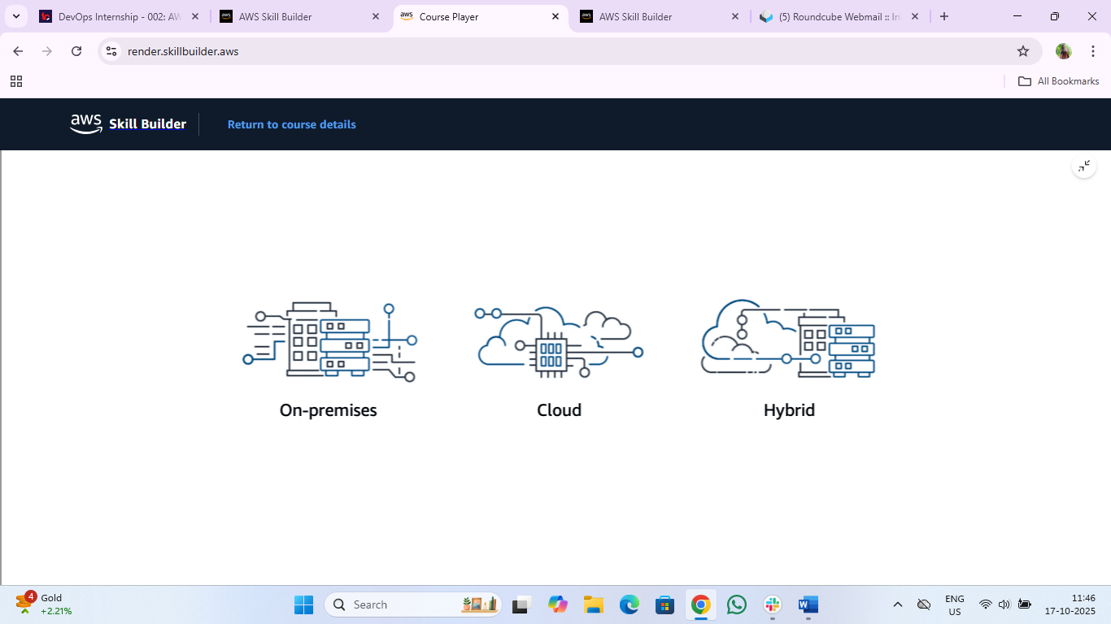
On-premises
Before the cloud, companies and organizations hosted and maintained hardware such as compute, storage, and networking equipment in their own data centres. For some companies and organizations, the cost of maintaining a large physical presence was unsustainable. To solve this problem, cloud computing emerged.
Cloud
on-demand delivery of IT resources over the internet with primarily pay-as-you-go pricing.
Hybrid
This type of deployment is a way to connect infrastructure and applications between cloud-based resources and existing resources that are not located in the cloud.

Advantages of cloud computing
- Pay-as-you-go: - paying only for the resources that you use.
- Benefits from massive economies of scale: - AWS can achieve higher economies of scale, which translates into lower pay-as-you-go prices.
- Stop guessing capacity: - You can access as much or as little capacity as you need and scale up and down as required with only a few minutes notice.
- Increase speed and agility: - IT resources are only a click away, this results in a dramatic increase in agility for the organization, because the cost and time it takes to experiment and develop is significantly lower.
- Realize cost savings: - with cloud computing, you can focus on your customers, rather than racking, stacking, and powering physical infrastructure.
- Go global in minutes: - Applications can be deployed multiple regions. This means that you can provide lower latency and a better experience for your customers at a minimal cost.
Resources:
- AWS website: What Is Cloud Computing?(opens in a new tab)
- AWS whitepaper: Types of Cloud Computing(opens in a new tab)
- AWS website: Cloud Computing with AWS(opens in a new tab)
- AWS whitepaper: Overview of Amazon Web Services

